Order Form For Helena Broome

Card | Title | Size | Unit Cost | Quantity
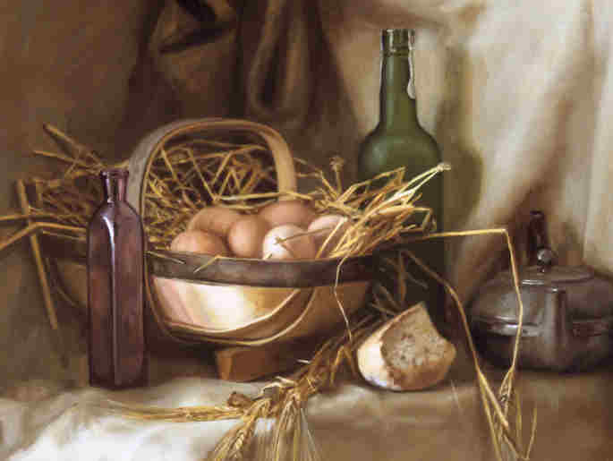 | Eggs In A Basket | Large | 1.75
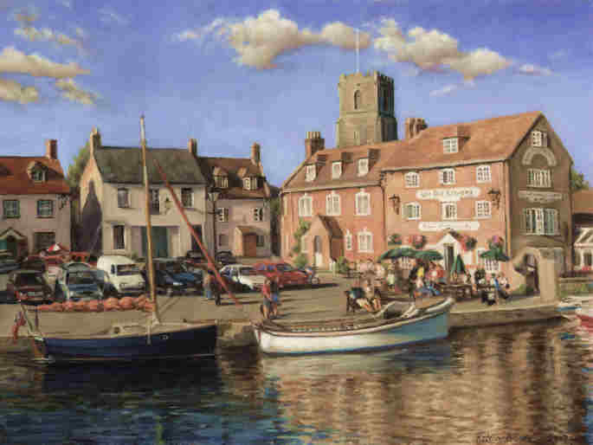 | Wareham Quay | Large | 1.75
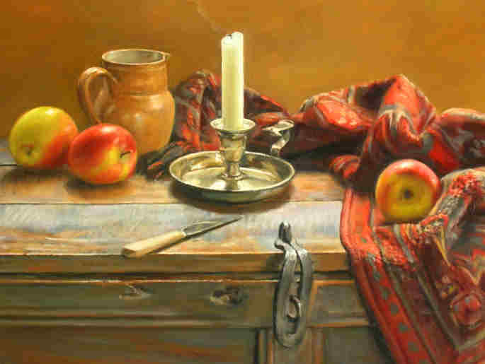 | Hope Chest | Large | 1.75
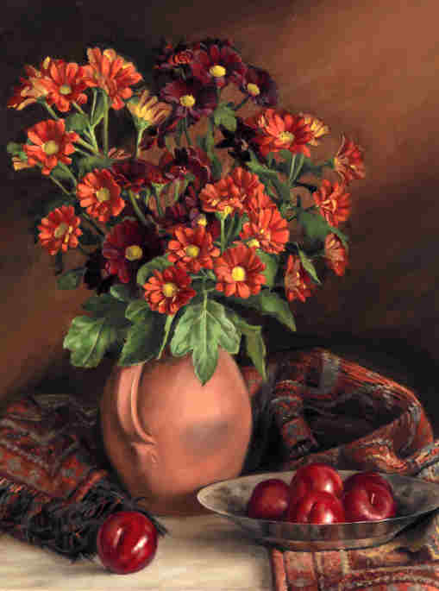 | Shades Of Autumn | Large | 1.75
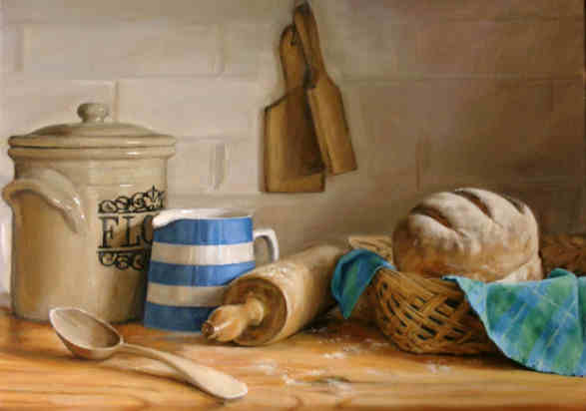 | Cornish Kitchen | Medium | 1.25
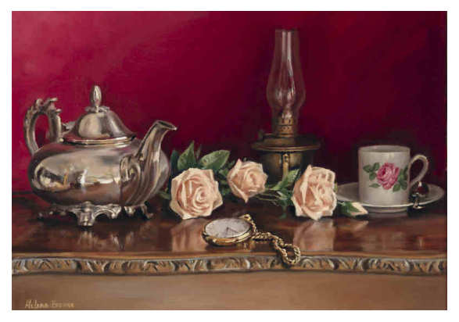 | Tea And Roses | Medium | 1.25
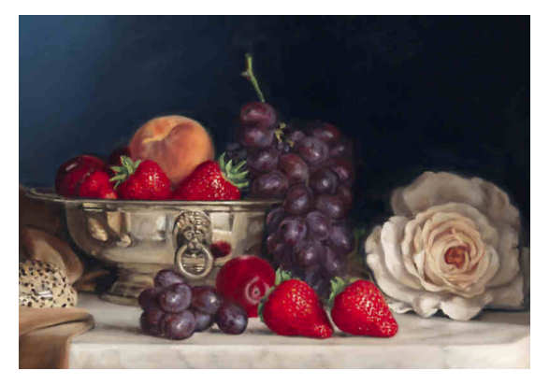 | Summer Reflections | Medium | 1.25
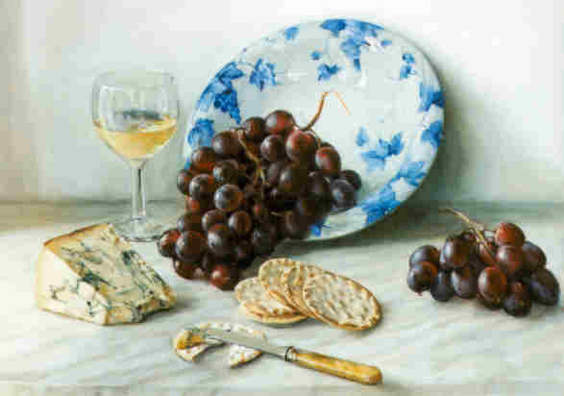 | Red Grapes And Blue Cheese | Medium | 1.25
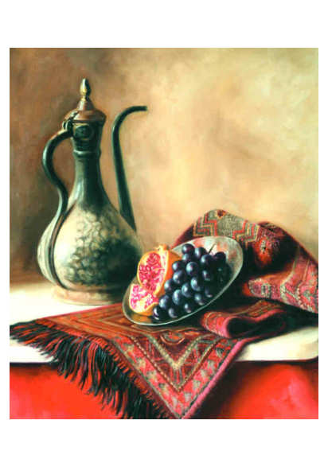 | Egyptian Pot | Medium | 1.25
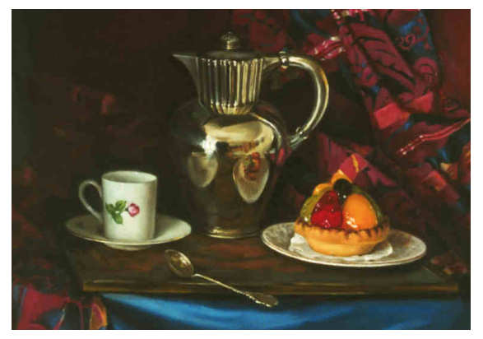 | Tartes Aux Fruits | Medium | 1.25
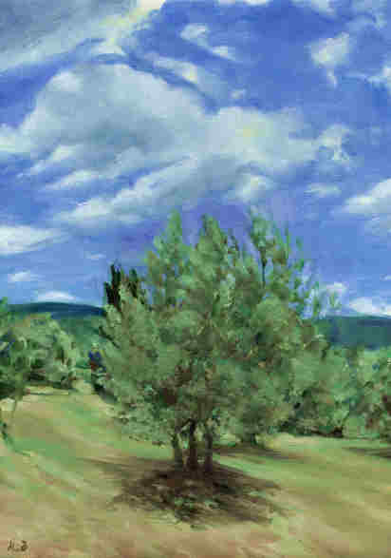 | Tuscan Olive | Medium | 1.25
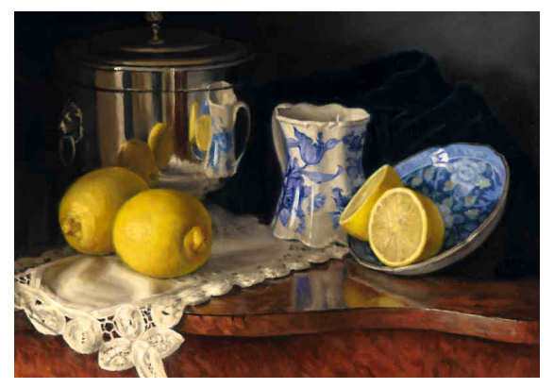 | Reflections In Silver | Medium | 1.25
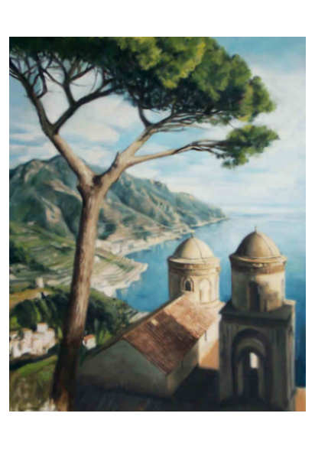 | Ravello On The Amalfi Coast | Medium | 1.25
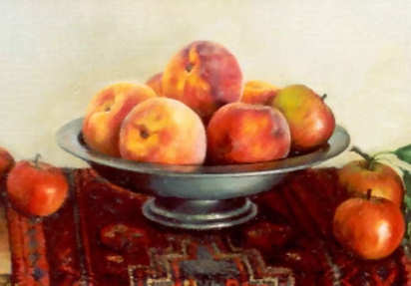 | Peaches | Small | 0.75
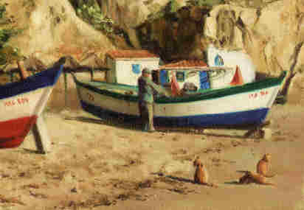 | Fishing Boats | Small | 0.75
 | A Good Read | Small | 0.75
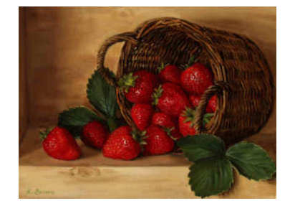 | Strawberries | Small | 0.75
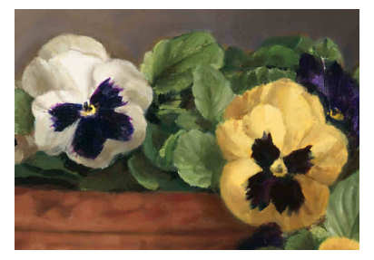 | Pansies | Small | 0.75
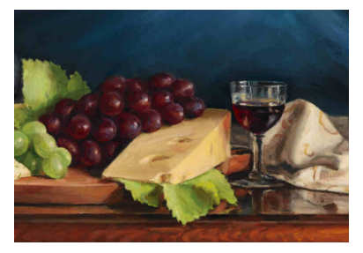 | The Cheese Board | Small | 0.75
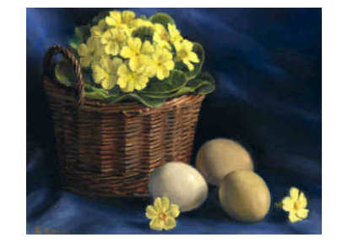 | Signs Of Spring | Small | 0.75

